**EX 7 IMPLEMENT PROGRAM FOR DECOMPOSING TIME SERIES**

**DATA INTO TREND AND SEASONALITY**

**DATE:**

**AIM:**

To decompose the AirPassengers time series dataset into trend, seasonality, and residual components using the multiplicative model.

**ALGORITHM:**

1. Load the AirPassengers dataset and parse the dates.
2. Set the 'Month' column as the index.
3. Apply the seasonal_decompose function with a multiplicative model and a period of 12.
4. Extract and analyze the trend, seasonality, and residual components.
5. Plot the original time series along with the decomposed components.

**PROGRAM:**

import numpy as np

import pandas as pd

import matplotlib.pyplot as plt

from statsmodels.tsa.seasonal import seasonal_decompose

# Load the AirPassengers dataset

df = pd.read_csv('/content/airline-passengers (1).csv', parse_dates=['Month'], index_col='Month')

df.columns = ['Passengers']

# Perform decomposition

result = seasonal_decompose(df['Passengers'], model='multiplicative', period=12)

# Plot the decomposition

plt.figure(figsize=(10, 8))

plt.subplot(411)

plt.plot(df['Passengers'], label='Original Time Series')

plt.legend()

plt.subplot(412)

plt.plot(result.trend, label='Trend', color='orange')

plt.legend()

plt.subplot(413)

plt.plot(result.seasonal, label='Seasonality', color='green')

plt.legend()

plt.subplot(414)

plt.plot(result.resid, label='Residual', color='red')

plt.legend()

plt.tight_layout()

plt.show()

**OUTPUT:**

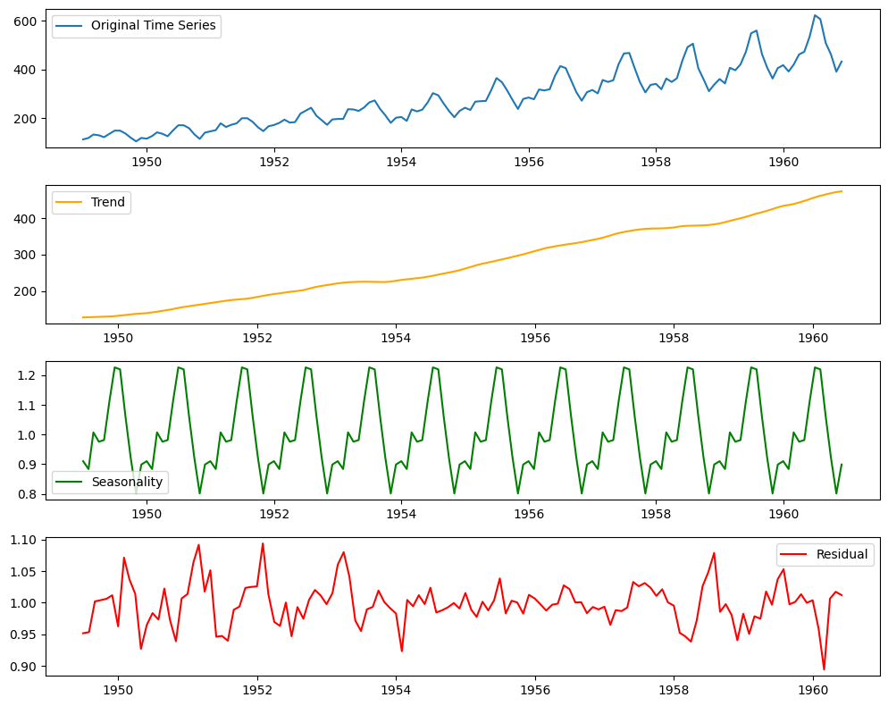

**RESULT:**

The time series decomposition reveals an increasing trend and a strong yearly seasonal pattern in the AirPassengers dataset. The residual component highlights fluctuations that are not captured by trend or seasonality.